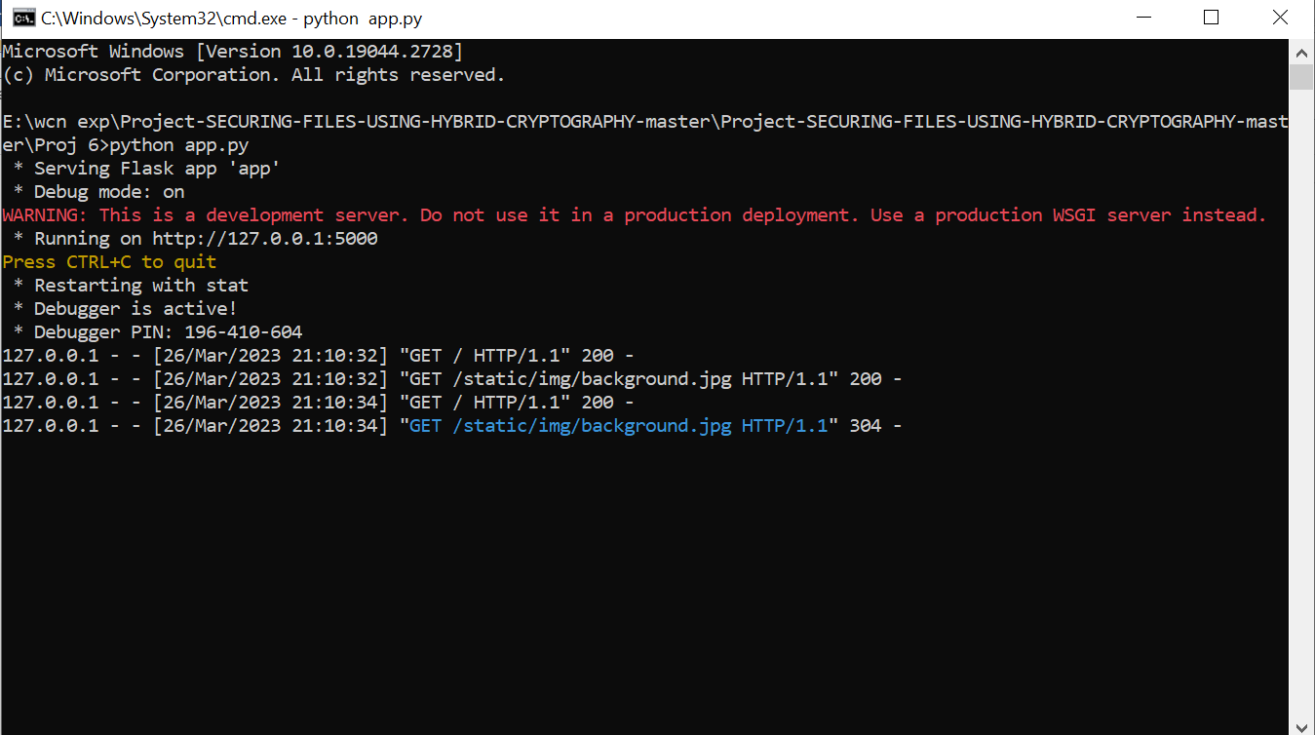**OUTPUTS:-**

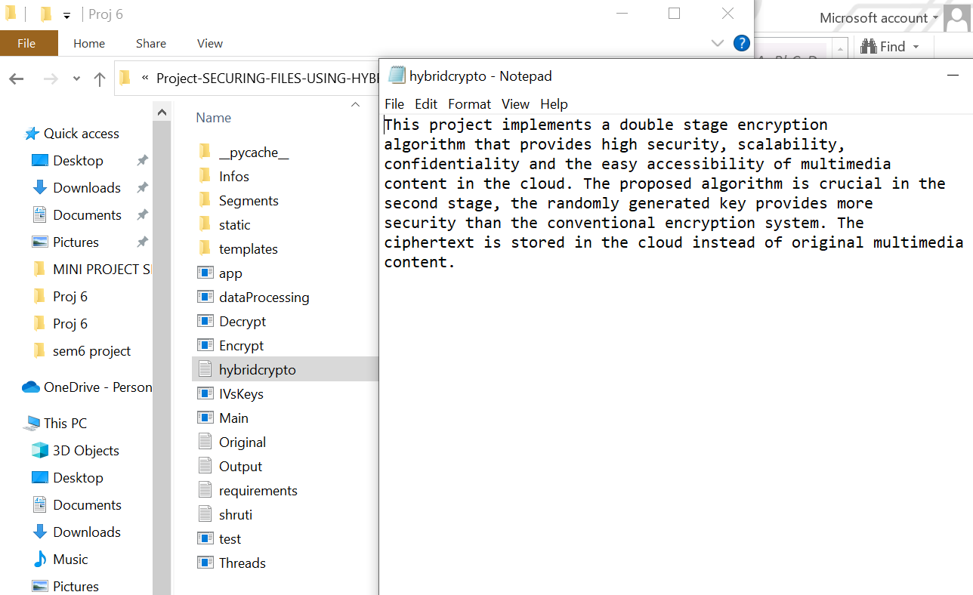**ORIGINAL FILE TO ENCRYPT & DECRYPT:-**

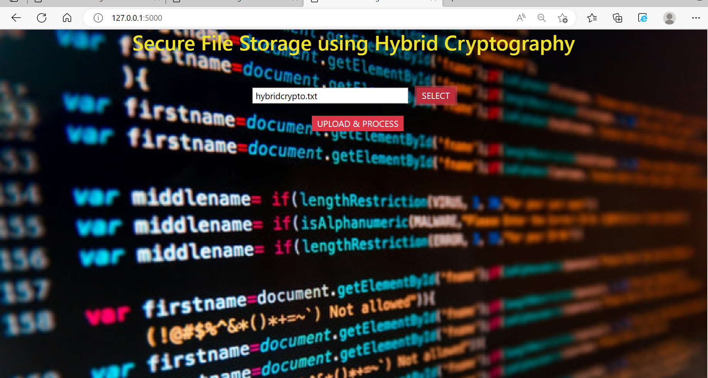**FILE UPLOADING & SELECTING PAGE:-**

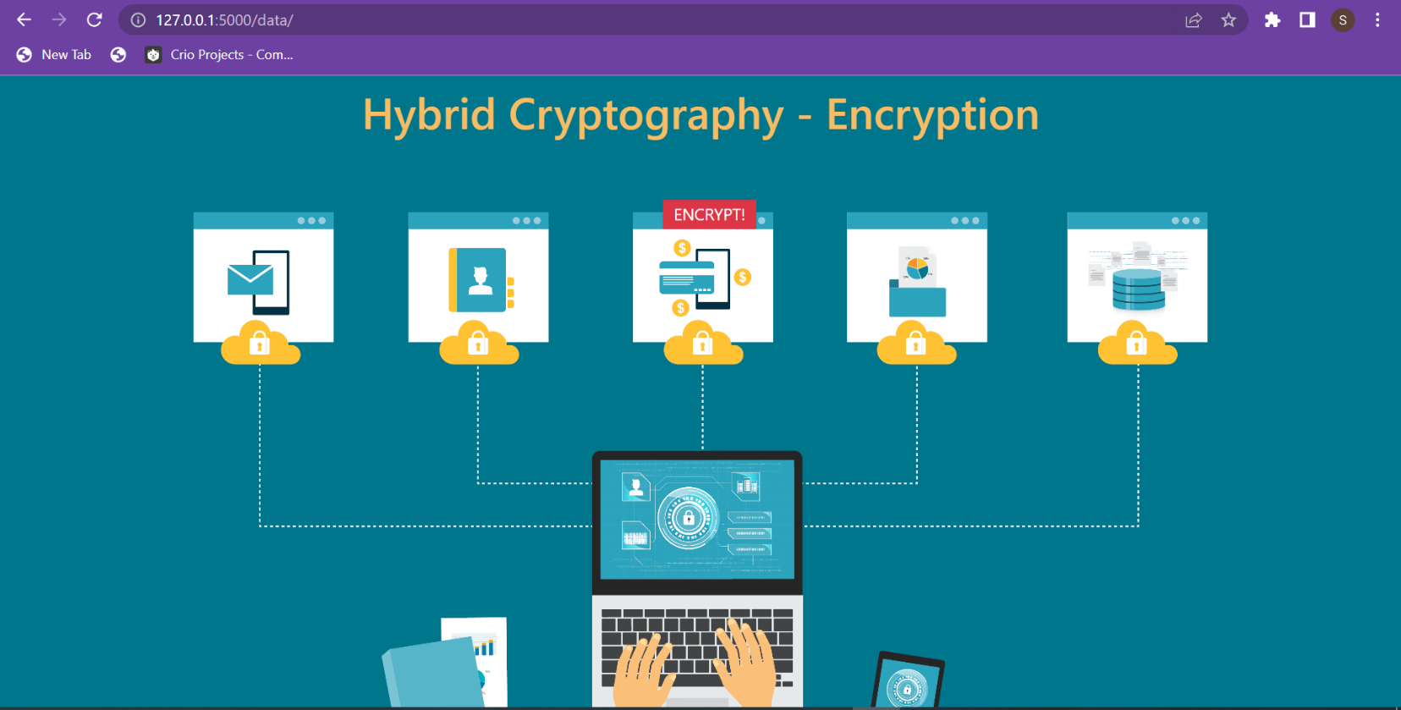 **FILE ENCRYPTION PAGE:-**

**FILE TO ENCRYPT:-**



**IF NO FILE CHOSEN:-**

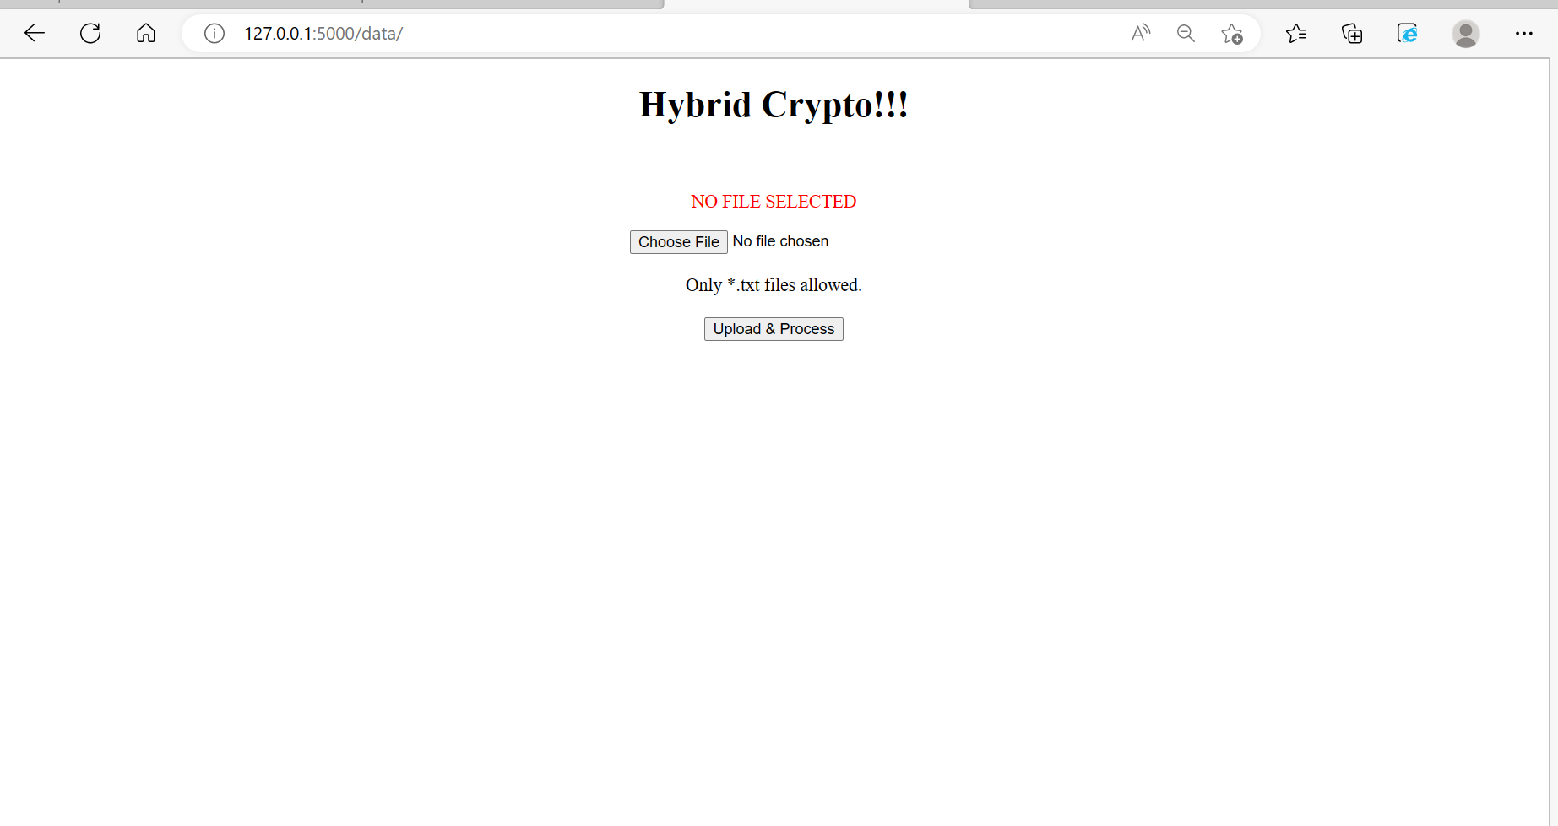

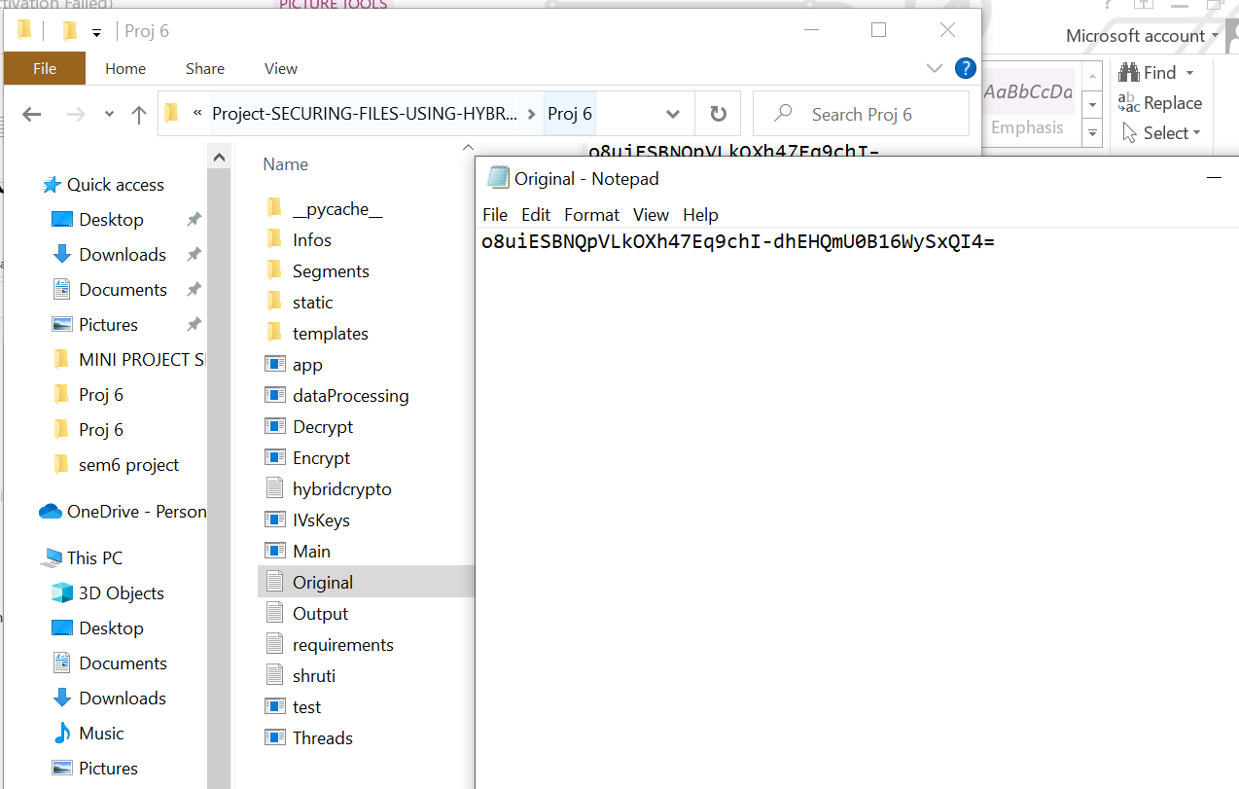**ONCE FILE GETS ENCRYPTED:-**

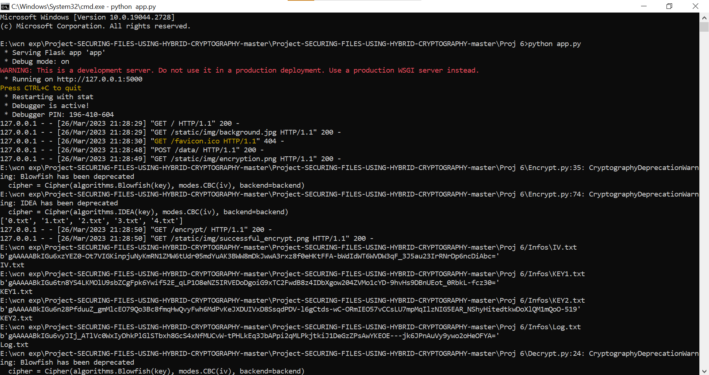**AFTER FILE ENCRYPTION:-**

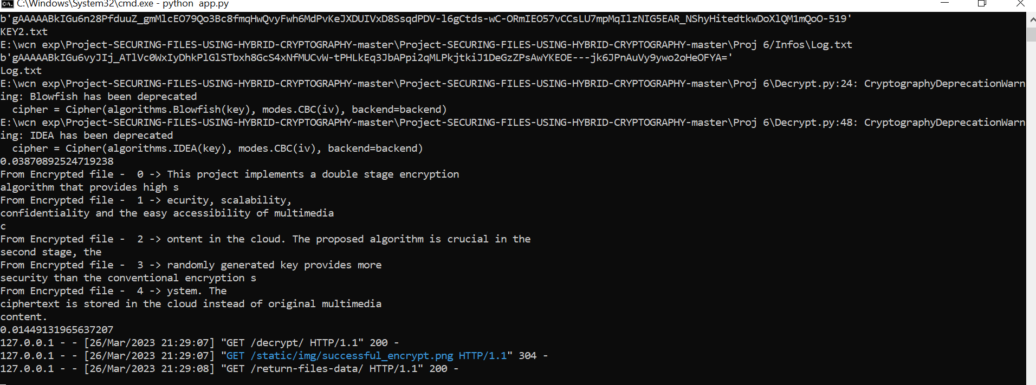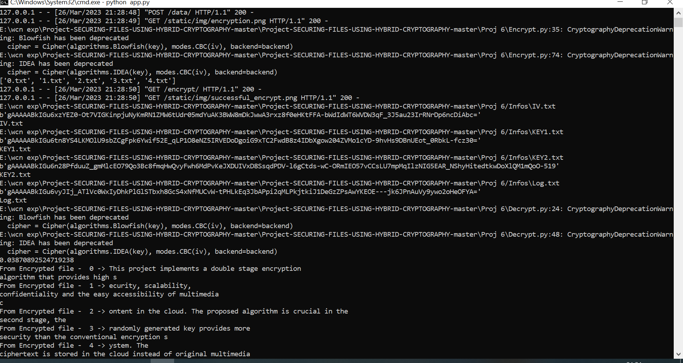

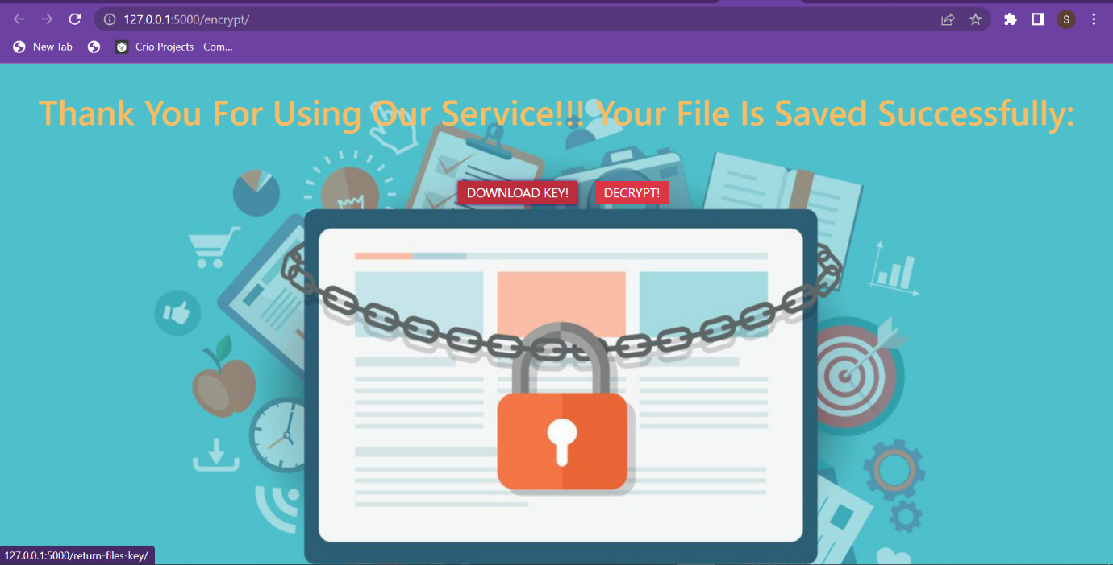 **TO DECRYPT FILE:-**

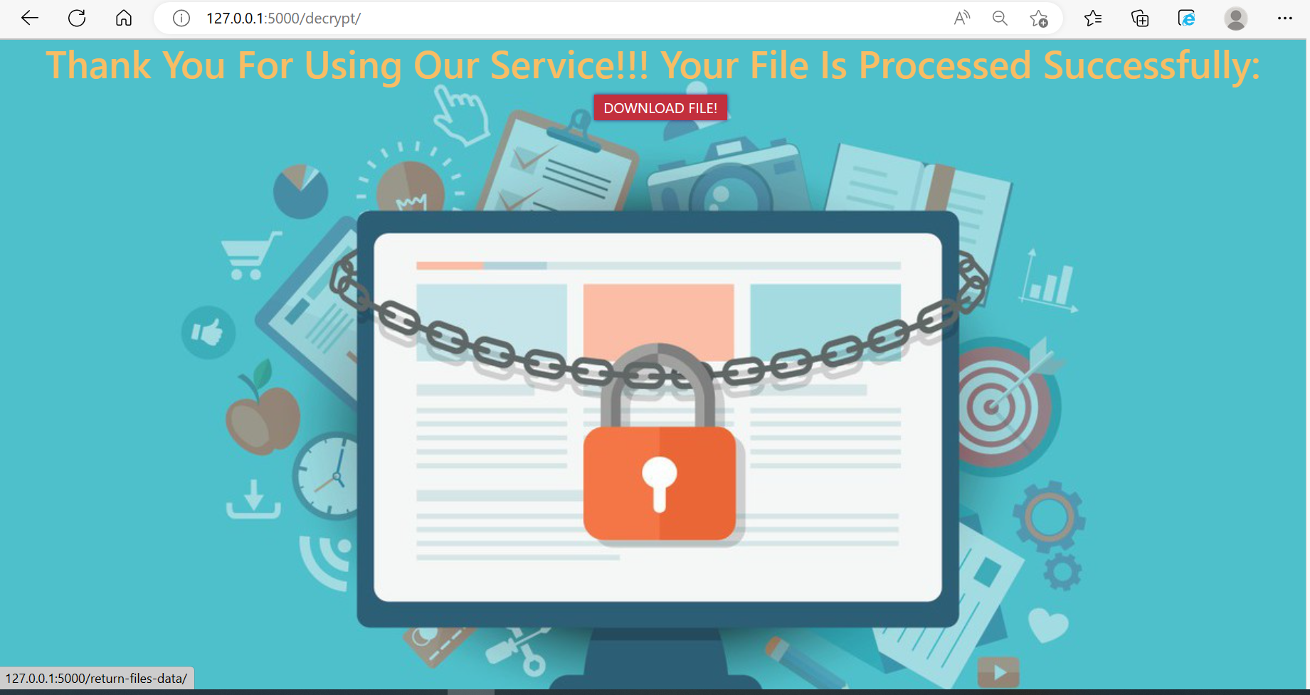**ONCE FILE GETS DECRYPTED:-**

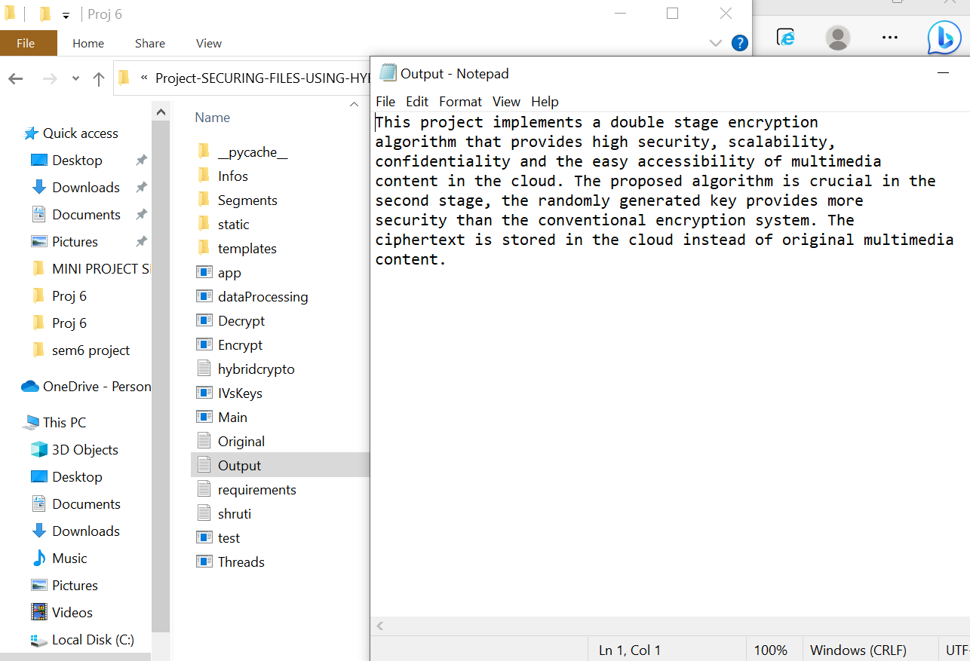**DECRYPTED FILE:-We got original final i.e. (deciphered file)**